Team Members: Anas Elhadidy, Eizat Mushtaq, Faisal Khan, Milan Ghori
Employee Benefit Management System
Fully Dressed Uc4

Revision History
Version | Date | Description | Author
1.0 | 10/01/2018 | First Draft of Fully Dressed Use Case 4  Comments:  - Level: User Goal Level  - Primary Actor: Management is an undefined Actor. Assume you meant Manager.  - Pre-conditions: Sounds like a step in this use case, not a precondition  - Special requirements: Like the update within 30 seconds | Eizat Mushtaq
1.1 | 11/05/2018 | Second draft of Fully Dressed Use case 4  Updates:  - Stake holders and interests, Preconditions, Post Conditions, Extensions, frequency of Occurrence and miscellaneous updated  - The main success scenario shows step by step process to execute the use case | Eizat Mushtaq

Table of Contents
No. | Contents | Page No.
1. | Fully Dressed Use case 4 | 3
2. | System Sequence Diagram | 5

Fully Dressed Use case 4:

Name | Manage vendors
Scope | Employee Benefit System
Level | User Goal
Primary Actor | Manager
Stakeholders and Interests | Manager – Would like to add/ delete the vendors for the employees  Employee – Would like to select the vendors for their benefits
Preconditions | Manager has been authorised by the system
Postconditions | The system should display the message “vendor successfully added”
Main Success Scenario | - The manager does manage vendors.  - The manager arrives at the system  - The manager enters his login details  - The system displays the main menu options to the manager  - The employee selects Manage vendor option.  - The system displays the manage vendor menu to the manager  - The manager can select the appropriate option.  - The manager enters the appropriate details and the system gives the message for successful execution of event.  - The system must update the information in the database.  - The system provides an option to manager to go back or logout  - The manager logs out from the system.
Extensions | N/A
Special Requirements | A system which can run the application
Variations in Technology and Data | The data must be entered through a keyboard.
Frequency of Occurrence | 10 requests/ minute
Miscellaneous | Explore possibility of handling a vendor out of business condition

Sequence Diagram:

Use case name: Manage Vendor
Scenario name: Add Vendor details

Description: In this Scenario, the manager adds a vendor to the system.

Path of the Scenario:
The scenario starts with the condition that the
- system is already running
- the Manager authenticates himself to the system.
The path for scenario is:
- The system shows the Manager menu to the manager.
- The manager selects the option corresponding to “Manage vendor”.
- The system then displays vendor menu to the manager.
- The manager selects the option corresponding to “Add vendor”.
- The manager enters the detail of each item asked by the system and upon completion gives message as “Vendor Updated”
- The system displays the vendor menu to the employee and the user selects the option “go back”.
- The system displays the manager main menu and he employee selects the option corresponding to logout.
- The system logs out the employee.

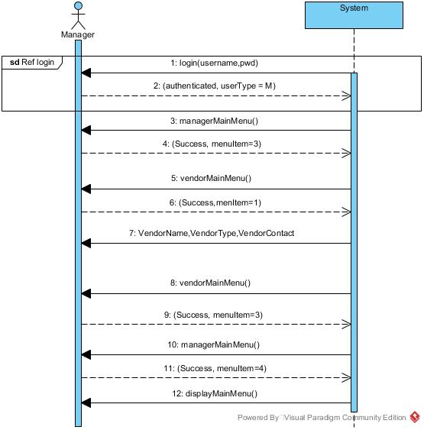
Add vendor sequence diagram

